A000-AM,C-Costa Rica-Guanacasta-Nicoya-Axe Deity-Jadeite-200 BCE-200 CE

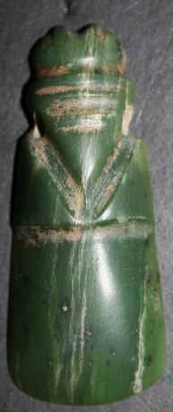 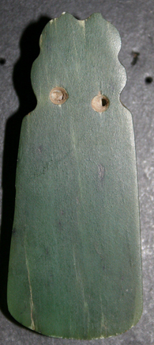

Fig. 1. Costa Rica-Guanacasta-Nicoya-Axe Deity-Jadeite-200 BCE-200 CE

**Case no.:**

**Accession Number:**

Formal Label: Costa Rica-Guanacasta-Nicoya-Axe Deity-Jadeite-200 BCE-200 CE

Display Description:

"The earliest known worked jade in Costa Rica (in the form of an axe god) was discovered at the site of La Regla on the Gulf of Nicoya."------1998, Juan Vicente Guerrero M., "The Archaeological Context Of Jade In Costa Rica," Jade In Ancient Costa Rica" p. 28.  
    "One of the most typical forms of Pre-Columbian Costa Rican lapidary work is the so-called axe-god, in which an animal, human being or a composite effigy surmounts a celt-like polished blade."--------1998, Michael J. Snarskis, "The Imagery And Symbolism Of Pre-Columbian Jade In Costa Rica," Jade In Ancient Costa Rica, p. 63.  
    "Common in the Costa Rican lapidary corpus are axe-gods with at first glance appear to be avian effigies. They are in fact part of a zoo-anthropomorphic continuum, with many jades having relative degrees of "birdness" and "humanness."."------1998, Michael J. Snarskis, "The Imagery And Symbolism Of Pre-Columbian Jade In Costa Rica," Jade In Ancient Costa Rica, p. 64.  
    "Outstanding among Costa Rican jades is the form long known in that country as the  dios-hacha, or axe god. The term encompasses conveniently all the stylized figure pendants shaped as though they had been made from axes of petaloid celts."--------1968, Elizabeth Kennedy Easby, "Pre-Columbian Jade From Costa Rica," p. 26.  
     "Costa Rican jadeite and greenstone artifacts can be divided into five basic categories: whole celt, half celt, quarter celt, and a general category of other forms. Most of the jade artifacts are pendants which appear to have been produced from raw material in the form of a celt."----1988, Mark L. Chenault, "Jadeite, Greenstone, And The Precolumbian Costa Rican Lapidary," Costa Rican Art And Archaeology, p. 99.  
    "The most impressive jade pendant (found on the Lama Corral 3 site in Costa Rica) was a virtually three-dimensional quetzal (bird found in Mexico to Panama) effigy axe god"---------2013, Michael Snarskis, "An Elite Burial Ground With Jade And Usulutan Ceramic Offerings," Pre-Columbian Art & Archaeology, Essays In Honor Of Frederick R. Mayer, p. 75.  
    "In Costa Rica, all artifacts made from green stone have traditionally been classified as "jade."---------1995, Marlin Calvo Mora, Leidy Bonilla Vargas & Julio San chez Perez, "Costa Rica, Gold, Jade, Forests," p. 77.

LC Classification: [F1545.3.P6](http://luna.wellesley.edu/search%7ES1?/mF1545.3.P6+C67+1988/mf++1545.3+p6+c67+1988/-3,-1,,B/browse)

Date or Time Horizon: 200 BCE-200 CE

Geographical Area: Motagua river valley in Guatemala

GPS: [14°56′57″N 91°00′32″W](https://tools.wmflabs.org/geohack/geohack.php?pagename=Motagua_River&params=14_56_57_N_91_00_32_W_region:_type:river)

Map: 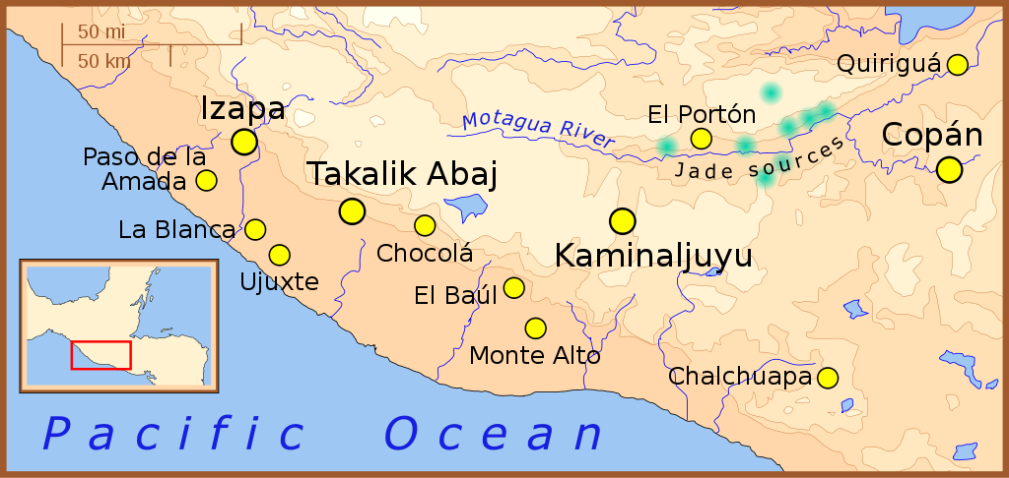

Fig. 2. A map of the southern-most area of [Mesoamerica](https://en.wikipedia.org/wiki/en:Mesoamerica), showing important Formative Period sites in yellow and jade sources in green

References

Jadeite locations taken from: Lallemant, Hans G. Avé ["Petrogenisis and Exhumation of Jadeitites in Guatemala"](http://cohesion.rice.edu/naturalsciences/earthscience/earthscience.cfm?doc_id=10025), Rice University, accessed February 2008.

Elevations based on those in the [Times Atlas of the World](https://en.wikipedia.org/wiki/en:Times_Atlas_of_the_World), 7th edition.

Location of archaeological sites taken from map for the upcoming book: "The Southern Maya Area in the Late Preclassic: Urbanism, Rulership, and Ethnic Interaction.", in press at the University Press of Colorado, Boulder, Michael Love and Jonathan Kaplan, eds.

Cultural Affiliation: Guanacasta-Nicoya

Medium: Jadeite

Dimensions:

Weight:

Provenance: Motagua river valley in Guatemala

Condition: original

Discussion: “Jade as it applies to Mesoamerica can only be jadeite, a sodium and aluminum silicate NaAlSi2O6 or Na(Al,Fe3+)Si2O6, a hard (Mohs hardness 6.5-7), sub-vitreous stone whose color ranges from blue-green, to apple green. The only known prehistoric source of jadeite in Mesoamerica is the Motagua River valley in Guatemala. If prehistoric peoples of Mesoamerica used this source alone rather than unknown or depleted multiple sources of the precious stone (such as Rio Balsas basin in Mexico, and the Santa Elena region in Costa Rica), then inter-regional trade must have been active in the exchange of this valuable élite stone.

Jade’s cultural significance is its green color, the color of plant life, which was associated with water, and vegetation (especially maturing maize).

Jade was traded and exchanged as a luxury item in Mesoamerica among elites, being replaced by gold ca 500 AD in Lower Central America. Jade artifacts are often found elite burial contexts, as personal adornments or accompanying objects.

Examples of Jade Artifacts

In the Formative period, the Olmec of the Gulf Coast were among the first Mesoamerican people to shape jade into votive celts, axes, and bloodletting tools around 1200-1000 BC. The Maya achieved master levels of jade carving. Maya artisans used drawing cords, harder minerals and water as abrasive tools to work the stone. Holes were made in jade objects with bone and wood drills, and finer incisions were often added at the end. Jade objects varied in size and shapes and included necklaces, pendants, pectorals, ear ornaments, beads, mosaic masks, vessels, rings, and statues.

Among the most famous jade artifacts from the Maya region we can include funeral masks and vessels from Tikal, and Pakal’s funeral mask and jewels from the Temple of the Inscriptions at Palenque. Other burial offerings and dedication caches have been found at major Maya sites, such as Copan, Cerros, and Calakmul.

During the Postclassic period, the use of jade dropped dramatically in the Maya area. Jade carvings are rare, with the notable exception of the pieces dredged out of the Sacred Cenote at Chichén Itzá. Among Aztec nobility, jade jewelry was the most valuable luxury: partly because of its rarity, since it had to be imported from the tropical lowlands, and partly because of its symbolism linked to water, fertility and preciousness. For this reason, jade was one of the most valuable tribute item collected by the Aztec Triple Alliance.

Jade in Southeastern Mesoamerica and Lower Central America

Southeastern Mesoamerica and Lower Central America were other important regions of the distribution of jade artifacts. In the Costa Rican regions of Guanacaste-Nicoya jade artifacts were mainly widespread between AD 200 and 600. Although no local source of jadeite has been identified so far, Costa Rica and Honduras developed their own jade-working tradition. In Honduras, non-Maya areas show a preference of using jade in building dedication offerings more than burials. In Costa Rica, by contrast, the majority of jade artifacts have been recovered from burials. The use of jade in Costa Rica seems to come to an end around A.D. 500-600, when there was a shift towards gold as the luxury raw material; that technology originated in Colombia and Panama.

Jade Study Problems

Jade artifacts cannot be dated themselves so that a secure chronological context is necessary. Oftenn jade objects were regarded as heirlooms heirlooms. A huge number of published items are from unknown provenience due to their having been looted.

References:

Balser, Carlos. 1980. Jade precolombino de Costa Rica. San José, Costa Rica: Instituto Nacional de Seguros.

Chenault, M.L., 1988. Jadeite, Greenstone, and the Precolumbian Costa Rican Lapidary-Chapter 5. In *Costa Rican Art and Archaeology: Essays in Honor of Frederick R. Mayer* (pp. 89-109).

Graham, M.M., 1992. Art-tools and the language of power in the early art of the Atlantic Watershed of Costa Rica. *Wealth and Hierarchy in the Intermediate Area, Dumbarton Oaks, Washington, DC*, pp.165-206.

Guerrero, J.V., 1998. The archaeological context of jade in Costa Rica. *Jade in Ancient Costa Rica*, pp.23-77.

Lange, Frederick W., 1993, Pre-Columbian Jade: New Geological and Cultural Interpretations. University of Utah Press.

Seitz, R., G.E. Harlow, V.B. Sisson, and K.A. Taube, 2001, Olmec Blue and Formative Jade Sources: New Discoveries in Guatemala, Antiquity, 75: 687-688/

Snarskis, M.J., 2003. From jade to gold in Costa Rica: How, why and when. *Gold and Power in Ancient Costa Rica, Panama, and Colombia*, pp.159-204.